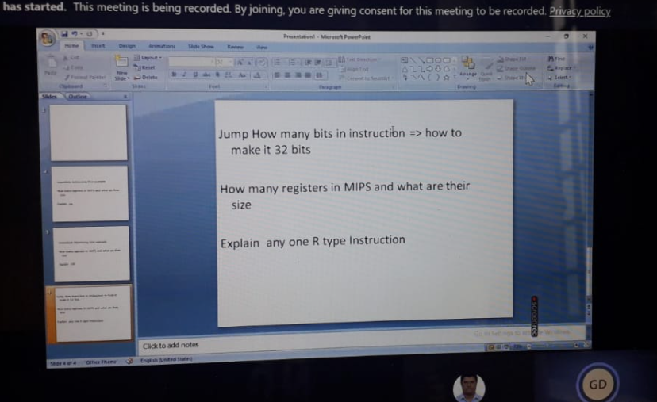

1. Jump how many bits change to 32

There is room in the instruction for a 26-bit address. The 26-bit target address field is transformed into a 32-bit address. This is done at run-time, as the jump instruction is executed.

Instructions always start on an address that is a multiple of four (they are word-aligned). So the low order two bits of a 32-bit instruction address are always "00". Shifting the 26-bit target left two places results in a 28-bit word-aligned address (the low-order two bits become "00".)

After the shift, we need to fill in the high-order four bits of the address. These four bits come from the high-order four bits in the PC. These are concatenated to the high-order end of the 28-bit address to form a 32-bit address.

1. how many registers in mips and their size

The MIPS processor has one standard register file containing 32 32-bit registers for use by integer and logic instructions.

1. explain any one R type instruction

These instructions are identified by an opcode of 0, and are differentiated by their funct values.

<https://www3.ntu.edu.sg/home/smitha/FYP_Gerald/instruction.html>